Plank

1. Lay on your chest.
2. Lift yourself up with your elbows, arms and feet.
3. Keep yourself still like a plank.
4. Flex your chest.
5. Hold this position for a certain amount of time.

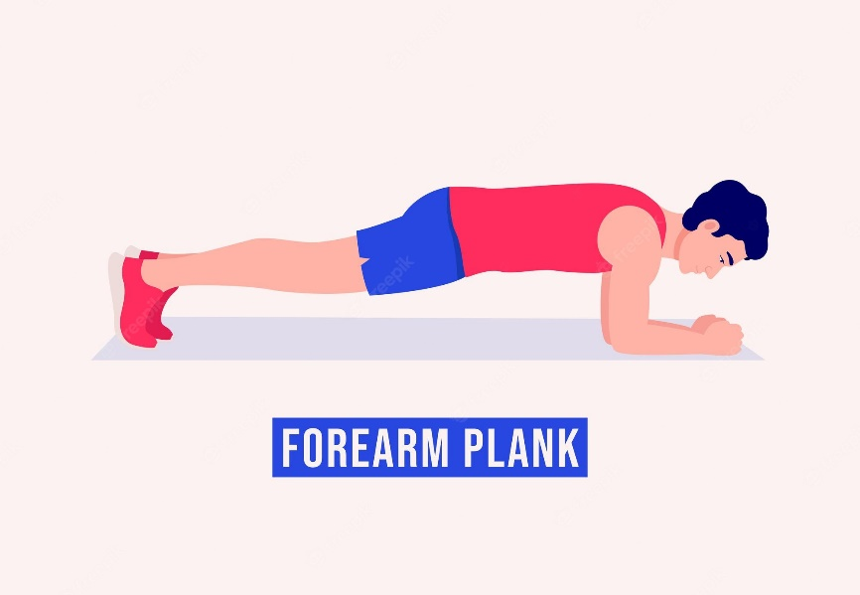

Horsekick

1. Go stand up straight.
2. Bend over with your hands to the ground.
3. Hit the grind with your hands and kick one of your legs in de air.
4. While placing your hands on the floor, swing your leg in the air.
5. Repeat this and switch legs.

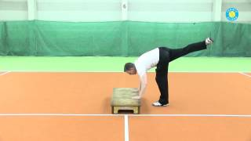

Mountain climbers

1. Go lay flat on your chest.
2. Go stand on hands and feet.
3. Keep your body in a straight line.
4. Keep your shoulders over your wrists.
5. Push your knee into your chest.
6. Do this with both legs.

